**EXPERIMENTS**

***Language is the principal tool with which we communicate; but when words are used carelessly or mistakenly,***

***what was intended to advance mutual understanding may in fact hinder it; our instrument becomes our burden***

— Irving M. Copi

# EXPERIMENT ON TEN RESEARCH ARTICLES – SECONDARY DATA

* 1. **INTRODUCTION**

## Background:

Journal articles have audience limited to peer group of researchers, scientists, journal reviewers and referees. The articles in journals are part of the study taken up by research students, ambitious scientists, doctors etc. The content of the journals consists of discussions, results, findings, processes, new research, criticizing existing research, and so on based on a theme that the author was trying to figure out during research or is trying to publish a recent finding that he or she may have already patented. These may also include review of literature from research papers and reviews from books. The journals cater to various kinds of specialized areas and therefore the journals are named on the basis of the specific area they cater to. For example, Nature Physics, Journal of the American Chemical Society, Angewandte Chemie, Astronomical Journal, Astrophysical Journal, Journal of Cell Biology, Genetics, Heredity etc.

The journals are rated and acquired status according to their impact factors. The impact factor (IF) defines on an average the paper refereed by other authors in their publications. IF is a measure of average number of citations to articles published in science and social science journals. The more the impact factor the more is the status of the journal. This indicates that more authors have referred to the particular article from that journal and have mentioned references in their own articles. In other words, any journal that publishes more number of review articles will have higher IF value. Every journal has a particular format for accepting articles. These formats differ depending on the affiliation the journal follows. For example the social science journals demand that authors submit the article in the APA (American Psychological Association). Example of APA format reference is given below:

Author, A. A., Author, B. B., & Author, C. C. (Year). Title of article. *Title of Periodical, volume number*(issue number), pages.

The above format will differ if the article is submitted for newspapers, magazines or for a review. Subscription to Journals in the past was available only in print form whereas they are now available online. These online journals are accessible by paying an amount known as the subscription charges. Individuals and their institutions can subscribe the journals as per their need.

## Importance of Publishing in a Journal:

For inspiring students and common people, research work of an author, researcher or an academician that is exceptional must get popularized and noticed. When this work gets published and popularized, the thoughts of the researcher are conveyed to the society. Along with the work and thoughts of the research, the author and his / her institution from where belongs will also get recognition. This helps in passing on the benefit of the researchers work to the society who reads it. The long term and quality of the work published always counts. For the researcher it is important that the published work should carry significant and sufficient novel research. The topic of research and methodology of work must be published in high impact peer reviewed journals. The researcher may have presented the work in a conference or a seminar and written in a style required by the publisher.

The first issue of Journal Nature was published on 4th November, 1869 (the international weekly journal of science). The objective of the journal is i) to place the results of scientific work and discovery before the general public, ii) to support the claims of science towards a general recognition in education and in daily life, iii) to provide information of all advances made in any branch of natural knowledge throughout the world to scientific men, and iv) giving an opportunity to discuss various scientific questions which arise from time to time.

## Importance of Tacit Knowledge:

Knowledge that is verbal and conveyed using informal means is known as tacit knowledge (TK). The TK may be difficult to write and is usually transferred from one person to another without formally documenting it. Generally, newspapers contain knowledge that is not supported by proofs, results or research, many a times it contains announcements of a particular technology or discovery or statements and comments. The scientific news contains proofs but is limited due to limitation of space in the format of the newspaper. Television broadcast news, displays cases supported with documentaries to make it interesting such as the science discovery, animal planet, etc. They try to accommodate facts, results, and investigations by making use of videos, sound etc. The important knowledge passed using verbal communication eg. teacher teaching in a class, a lawyer concluding his case, a doctor explaining the problem and solutions to the patient etc. are perishable. Very little part of the complete discussion or communication is reproduced. Though this kind of exchange of discussion and knowledge imparted is faster and is not documented, many a times perishes from our minds. Michael Polanyi in 1958 first introduced the term tacit knowledge or tacit knowing. This TK emerges out of socializing, learning to ride a cycle, driving a car etc. Though TK consists of beliefs, values, ideas, these are deeply ingrained in people, therefore often taken for granted. The art of carpentry, designing, conceptualizing etc. are possessed only by individuals and difficult to communicate to others through words or symbols.

In order to make facts clear and crisp, a well documented document to record the methods, results and designs is important, so that they are available to the next generation and to the society for gaining and sharing the knowledge. Therefore, journals have adapted themselves to receive such findings, designs, graphs, data, compilation, analysis, results etc. as a document in the form of a format for wider publicity and to enhance the audience or the masses.

Researchers document some of the important TK they carry out during experimental research. This documentation along with observations, facts and results is written by them and conveyed via publications. These publications so called research articles must be written in simple prose for being understood by the common people and students. For this to happen, the researcher has undertaken an experiment of 10 research articles which have relevance to common people. These experimental articles are focused on the theme of the research article. To make it simpler it has been put into various sub-headings under each experiment.

# DESCRIPTION OF EXPERIMENTS

An experiment consisting of ten research articles from journals of repute was carried out to examine the language, understandability, relation, simplicity, usefulness it contains to the students and common people.

## Testing:

The parameters under testing were the following:

1. Language,
2. Understandability,
3. Relation,
4. Simplicity,
5. Usefulness
6. Publicity

## Details of the Experiments:

Ten publications from CSIR-NCL’s scientist as authors were taken based on the research papers relevance to the common people. These were randomly selected by studying the implications of the papers by noting the use and impact of research work recorded in the research publication. Only one article has been taken for study under each experiment. The number of references other than the article under study refers to the sources that were required to study the article. Following is a list of references of ten research articles that have been taken for the study.

Experiment 1 - Article 1:

1. Ashok P. Giri**,** Abhay M. Harsulkar, Vasanti V. Deshpande, Mohini N. Sainani, Vidya S. Gupta, and Prabhakar K. Ranjekar, *Plant Physiology*, **116** (1998), 393-401.

Experiment 2 - Article 2:

1. Mahesh Kulkarni, et. al.,(2012), Journal of Proteome Research, 2012, 11, 1391−1396
2. Manasi Telang, Ajay Srinivasan, Aparna Patankar, Abhay Harsulkar, Vijay Joshi, Archana Damle, Vasanti Deshpande, Mohini Sainani, Prabhakar Ranjekar, Gorakh Gupta *et al., Phytochemistry,* **63** (2003), 643-652.

Experiment 3 - Article 3:

1. Lohokare, H. R., Bhole, Y. S. and Kharul, U. K. (2006), Effect of support material on ultrafiltration membrane performance. J. Appl. Polym. Sci., 99: 3389–3395.
2. Lohokare, H. R., Kumbharkar, S. C., Bhole, Y. S. and Kharul, U. K. (2006), Surface modification of polyacrylonitrile based ultrafiltration membrane. J. Appl. Polym. Sci., 101: 4378–4385.

Experiment 4 - Article 4:

1. Dhar, S., Reddy, E. Maheswara., Shiras, A., Pokharkar, V. and Prasad, B. L. V. (2008), Natural Gum Reduced/Stabilized Gold Nanoparticles for Drug Delivery Formulations. Chem. Eur. J., 14: 10244–10250.

Experiment 5 - Article 5:

1. Chandravanu Dash and Mala Rao (2001), Interactions of a Novel Inhibitor from an Extremophilic *Bacillus* sp.with HIV-1 Protease, The Journal Of Biological Chemistry, Vol. 276, No. 4, Issue of January 26, pp. 2487–2493, 2001.

Experiment 6 - Article 6:

1. The extracellular constitutive production of chitin deacetylase in Metarhizium anisopliae: possible edge to entomopathogenic fungi in the biological control of insect pests, Pallavi Nahar, Vandana Ghormade and Mukund V. Deshpande, Journal of Invertebrate Pathology, Volume 85, Issue 2, February 2004, Pages 80-88.
2. Comparative Evaluation of Indigenous Fungal Isolates, Metarhizium anisopliae M34412, Beauveria bassiana B3301 and Nomuraea rileyi N812 for the Control of Helicoverpa

armigera (Hub.) on Chickpea, Pallavi Nahar, Mahesh Kulye, Priya Yadav, Mounir Hassan, Urs Tuor, Siegfried Keller and M.V. Deshpande, Journal of Mycology and Plant Pathology, Volume 33, Issue 3, 2003, Pages 372-377.

Experiment 7 - Article 7:

1. Amudeswari, P. Saravanan, J. Raghava Rao and T. Ramasami, (2009) ‘Leather Bioprocessing: A Greener Finish’, Biotech News, 4:7, February, page 4.

Experiment 8 - Article 8:

1. ‘Application of Cellulases From an Alkalothermophilic Thermomonospora sp. In Biopolishing of Denims’, (2007), Biotechnology and Bioengineering, Vol. 96, No. 1, January 1.

Experiment 9 - Article 9:

1. Choudhary, V. R., et. al., (2005), Simultaneous Conversion of Methane and Methanol into Gasoline over Bifunctional Ga-, Zn-, In-, and/or Mo-Modified ZSM-5 Zeolites. Angew. Chem., 117: 4455–4459. doi: 10.1002/ange.200500694

Experiment 10 - Article 10:

1. S. R. Thengane, et. al., Current Science, 90:10, 25 May 2006, ‘Micropropagation of Indian laurel (Calophyllum inophyllum), a source of anti-HIV compounds’.
2. Pawar KD, et. al., Journal of Biotechnology 130 (2007) 346–353, Pattern of anti-HIV dipyranocoumarin expression in callus cultures of Calophyllum inophyllum Linn.

# ANALYSIS OF THE EXPERIMENT

## Description of the Experiments:

Ten experiments were conducted on ten different research articles published by the authors of CSIR-NCL. The articles were selected randomly based on the relevance and application of the research work for the common people. Each experiment was searched for its publicity using

goggle and the article reference was scanned using goggle scholar. The main theme of the publication has been noted from sources like newspapers, reports and advertisements.

## Analysis of the Experiments:

Each experiment has been studied and discussed with the concerned scientist. The importance of doing the experiment was to find out the popularity of the research carried out and whether the efforts taken by the researchers reach the common people. The method used for reaching out to the common people was noted and produced in the result. The image is taken from sources like newspapers clippings, articles published from a popular science journal and not from a scholarly journal.

## Method Used:

The experiments have been read analysed. To bring out the true simplicity and meaning of the experiment, they have been split into parts. These parts have been named using words relevant to the common people’s understanding. Table 4.3 describes the terms used in the experiments.

## Nomenclature Used in the Experiments:

Each experiment has been analysed to find out the relevance and importance of the study undertaken. The experiment was split thereby depicting the title, analysis, findings, results and data to support. Refer table 4.3. The title of the analysed article was modified to depict a clear and simple title that can help the reader to know at a glance the content of the article, its importance and relevance to the society. The original title of the article was confusing and not properly understood by the students and common people. This was brought out during the analysis of the questionnaire using secondary source. A research paper / article were given to the students and questions were asked through the questionnaire method (more details are given in the Research Methodology Chapter). The experiments have been arranged randomly in series and each has been analysed.

## TABLE 4.3. – NOMENCLATURE USED IN EACH OF THE TEN EXPERIMENTS

|  |  |  |
| --- | --- | --- |
| S. No | Experiment Nomenclature | Experiment Analysis |
| 1. | Title | Title of the Experiment |

|  |  |  |
| --- | --- | --- |
| 2. | Introduction | Problem |
| 3. | Introduction | Background |
| 4. | Analysis | Existing Technology |
| 5. | Analysis | Lessons to Learn |
| 6. | Analysis | Methods |
| 7. | Findings | Observation |
| 8. | Result | Lessons to Learn |
| 9. | Result | Publicity |
| 10. | Conclusion | Contribution from CSIR-NCL |
| 11. | Support Data | References |
| 12. | Support Data | Image of an Original Article |

* 1. **IMPORTANT, RESULTS AND DISCUSSION**

The analysis of each experiment is given in details. The importance, result and discussion are included in each article pertaining to the particular article in the form of Title, Problem, Background, Existing Technology, Lessons to learn, Observation, Methods, Contribution from CSIR-NCL, Publicity, Reference and Original Article.

# RESULTS OF STUDY

The researcher has taken ten publications based on their relevance to the common people.

## Methodology Used for Primary Data Experiment 1

**Method For Identifying Proteinase Inhibitors In Plants For Developing Pest Resistance In Crops**

### *Problem:*

The low yield of crops is due to the insect’s attack that also causes significant economic losses. Conventional pesticides are not effective against insect pests as they develop resistance against them and these chemical pesticides cause environmental hazards.

### *Background:*

It is a routine with farmers to use pesticides for the control of pests in their crops. These pesticides many a times cause harm to the plants and toxic to soil microorganisms and other beneficial insects. CSIR-NCL developed a technology (method) to identify proteinase inhibitors that could be expressed in plants for developing pest resistant in variety of crops. Chickpea and tomato were chosen by CSIR-NCL for trying out their new technology.

### *Observation:*

The method used by CSIR-NCL is by using natural defense mechanism of plant for protein crop and is found to be environment friendly.

### *Method:*

The plants in order to defend themselves against insect attack, synthesizes a wide range of molecules. Proteinase inhibitors (PIs) present on the plant plays a defensive role against pests and pathogens. The PIs are naturally found, containing defense-related proteins (properties) often present in seeds and induced in certain plant tissues by way of insect chewing. The PIs synthesized by a plant might not be effective against all insects. To engineer defense against an insect, there is a need to identify the particular PIs that will inhibit growth of that specific insect.

Plants that do not naturally produce such PIs can then be protected against that specific insect by transferring the genes responsible for PI production. This will produce a transgenic or genetically engineering plant variety that is pest-resistant, without use of pesticides.

### *Contribution from CSIR-NCL:*

For example, the Gram Pod Borer (*Helicoverpa armigera*) is a devastating pest of many commercially important crop plants including cotton, chickpea, pigeonpea, sunflower, tomato, okra etc. Dr. Vidya Gupta and Dr. Ashok Giri along with their team at NCL found that the Pod borer disarms the host plant’s natural defense mechanism by inactivating PIs and, then feeds on them. As the PI found in the host plant is ineffective, Dr. Gupta’s team screened several other plants that were resistant to the Pod Borer and identified PIs from these plants. Their studies revealed that when PIs from winged bean, bitter gourd, capsicum, potato and groundnut were fed to the Pod Borer, its growth and, egg-laying/hatching abilities were dramatically retarded. Dr. Gupta’s team has focused on four PIs from the seeds of winged bean (known as ‘chaudhari wal’) that were found to be most effective against the Pod Borer. They then isolated the genes responsible for these PIs and successfully transferred these genes to bacteria and yeast. The PIs synthesized by these organisms show effective activity against the Pod Borer.

### *PUBLICITY:*

* + - * 1. This work has been highlighted on cover page of the journal Phytochemistry
        2. Feature article by Dr. R. A. Mashelkar, Director General, CSIR & Secretary, Department of Scientific & Industrial Research, Press Information Bureau, Govt. of India, <http://pib.nic.in/feature/feyr98/fe0798/PIBF2107981.html>
        3. Pursuit and Promotion of Science, chapter 25, Pp. 254, INSA publication, <http://www.iisc.ernet.in/insa/ch25.pdf>
        4. See popular article in TOI given below for publicity-20th July, 2007

## Figure 4.5.1 – Paper Clipping dated 20th July, 2007– Popularisation Purpose

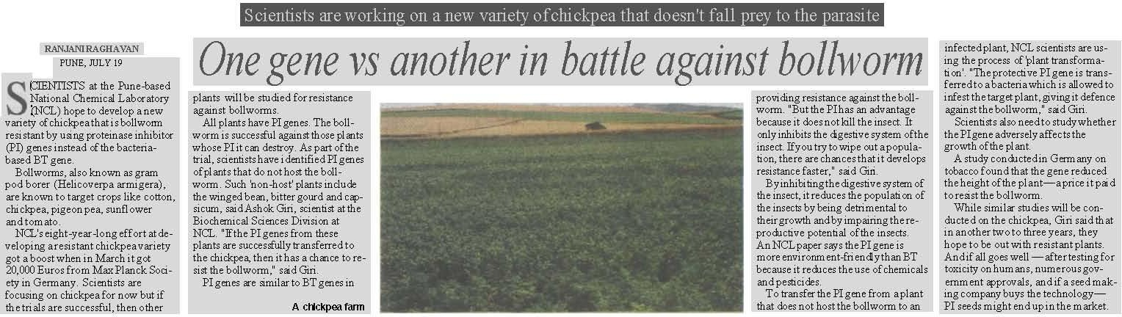

**Figure 4.5.2 – Article Published on Journal Cover Page – Popularisation Purpose**

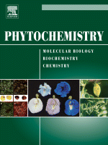

### *1.7. References:*

* + 1. Ashok P. Giri**,** Abhay M. Harsulkar, Vasanti V. Deshpande, Mohini N. Sainani, Vidya S. Gupta, and Prabhakar K. Ranjekar, *Plant Physiology*, 116 (1998), 393-401.
    2. Shu-Guo FAN and Guo-Jiang(2005), Characteristics of plant proteinase inhibitors and their applications in combating phytophagous insects, Bot. Bull. Acad. Sin. (2005) 46: 273-292)
    3. <http://www.nclinnovations.org/pdfs/techmaking/ncl/2003may15-pestresistant-plants.pdf>
    4. Ashok P. Giri, Abhay M. Harsulkar, Maurice S. B. Ku, Vidya S. Gupta, Vasanti V. Deshpande, Prabhakar K. Ranjekar and Vincent R. Franceschi, *Phytochemistry,* 63 (2003), 523-532.
    5. Manasi Telang, Ajay Srinivasan, Aparna Patankar, Abhay Harsulkar, Vijay Joshi, Archana Damle, Vasanti Deshpande, Mohini Sainani, Prabhakar Ranjekar, Gorakh Gupta *et al., Phytochemistry,* 63 (2003), 643-652.
    6. Abhay M. Harsulkar, Ashok P. Giri, Aparna G. Patankar, Vidya S. Gupta, Mohini N. Sainani, Prabhakar K. Ranjekar, and Vasanti V. Deshpande, *Plant Physiology*, 121 (1999), 497-506.
    7. Personal Discussion with Dr. Ashok Giri at CSIR-NCL.
* For further information on this work, contact Dr Vidya Gupta (vs.gupta@ncl.res.in) or Dr. Ashok Giri at [ap.giri@ncl.res.in.](mailto:ap.giri@ncl.res.in)

### *4.5.1.8 Original article is below:*

**Figure 4.5.3. Original Snapshot of a Typical Research Paper.**

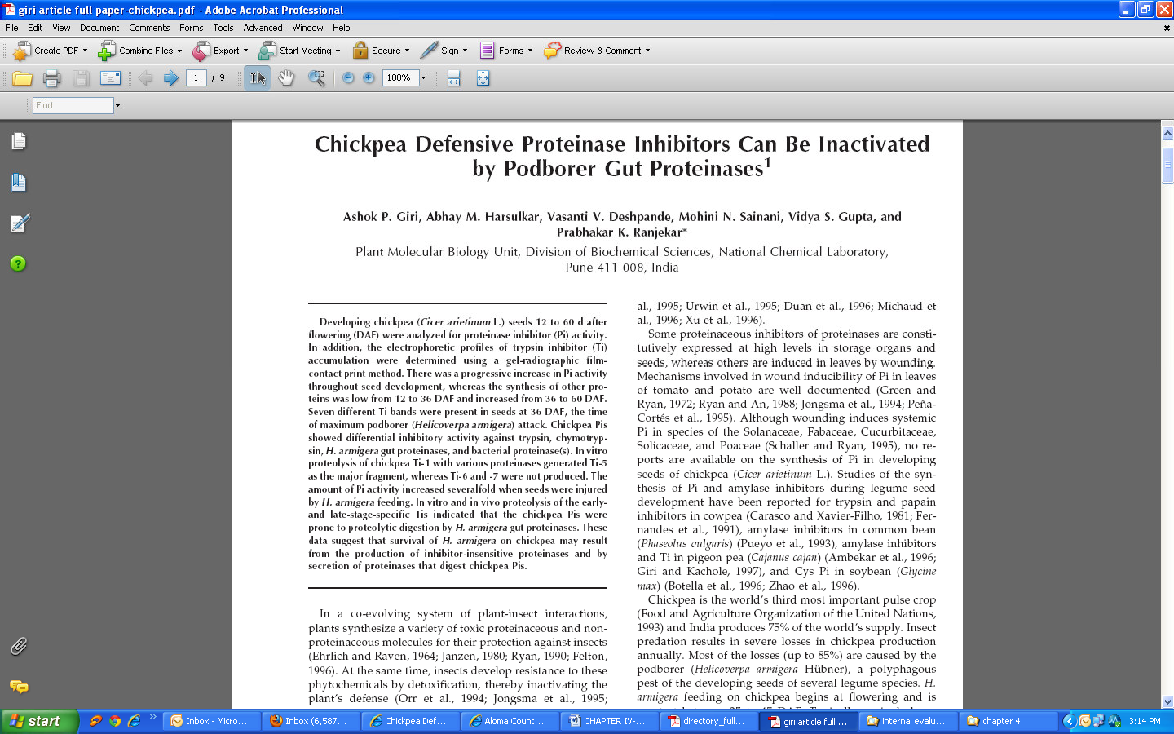

Source: [http://www.plantphysiology.org/content/116/1/393.full.pdf+html](http://www.plantphysiology.org/content/116/1/393.full.pdf%2Bhtml)

# Results of Study

## Methodology Used for Primary Data Scientific Discovery No. 2

**Tuberculosis (TB) drugs helps Diabetes patient**

### *Problem:*

Due to diabetes, blood sugar level increases leading to the development of complications in human body. This happens because of a non-enzymatic reaction (non-enzymatic means, the protein or the lipid molecule bonds with the sugar molecule such as fructose or glucose without controlling the action of an enzyme, termed as glycation) between glucose and proteins contained in the body. Glycation of proteins lead to the formation of Advanced Glycation End products (AGEs).

Therefore, the sugar level in a diabetes patient needs to be monitored and kept at a safe level.

### *Background:*

When the blood sugar level rises, Glycation may occur. If this occurs inside the body it is termed as endogenous glycation and when it occurs outside the body it is termed as exogenous glycation. Much of the early laboratory research work on fructose glycations used inaccurate analysis techniques causing an extreme underestimation of the importance of fructose in glycation.

### *About the Existing Drug:*

The drug rifampicin is already patented and therefore the Patent Act of India does not allow to re-patent it, so it can only be repositioned (the property of the drug can be used for a different application) as a potent anti-glycating molecule for the treatment of diabetic complications. It can be used to treat ageing, Alzheimer’s diseases and Parkinson’s disease.

### *Lessons to learn:*

Repositioning of drugs that is, finding new use for an already existing drug has become an important area of research in the pharmaceutical industry in the last few years. Recent examples of successful repositioning by drug companies include Viagra and Thalidomide.

A significant advantage of drug repositioning is that the repositioned drug has already passed toxicity tests and its safety profile is known.

### *Observation:*

It is observed by Dr. Mohan Magdum, consultant diabetologist and endocrinologist, Jehangir Hospital, that most of the diseases with problems of tissue damage including diabetes result in glycation of body proteins leading to increase in tissue diameter. According to him, “if a glycation inhibitor can be used, it should logically help in controlling the long term damage of such diseases and can go a long way in the treatment of diabetes.”

### *Method:*

Much of the early laboratory research work on fructose glycations used inaccurate assay techniques that led to drastic underestimation of the importance of fructose in glycation.

### *Contribution from CSIR-NCL:*

Dr. Mahesh Kulkarni and his team, have found that rifampicin shows higher glycation inhibition, a major intervention strategy in diabetic complications. Scientists at the NCCS (National Centre for Cell Science) are now involved in the animal and clinical trial of the study. CSIR-NCL is also working on the repositioning of various other existing drugs.

* + - * + For further details kindly contact Dr. Mahesh Kulkarni at [mj.kulkarni@ncl.res.in.](mailto:mj.kulkarni@ncl.res.in)

### *Publicity:*

1. <http://www.nclinnovations.org/pdfs/techmaking/IE-23-05-2010.pdf>
2. Article in Indian Express dated 23rd May, 2010
3. <http://www.indianexpress.com/news/tb-drug-may-bring-relief-to-diabetics/622543/0>

## Figure 4.5.2.1. Paper Clipping – Popularisation Purpose

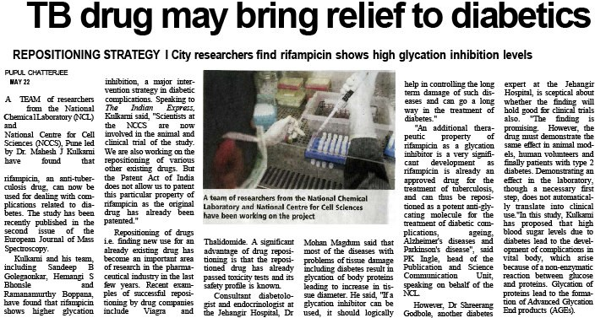

### *4.5.2.8. References:*

1. Bhonsle, Hemangi S.; et. al. (2008), 15:7, pp. 663-667 (5), Protein and Peptide Letters.
2. Sandeep B. Golegaonkar, Mahesh J. Kulkarni *,et. al, European Journal of Mass Spectrometry,*16:2, Pages 221–226 (2010) doi: 10.1255/ejms.1066,
3. <http://www.nclinnovations.org/pdfs/techmaking/IE-23-05-2010.pdf>

### *4.5.2.9 Original article is below:*

**Figure 4.5.2.2. Original Snapshot of a Typical Research Paper.**

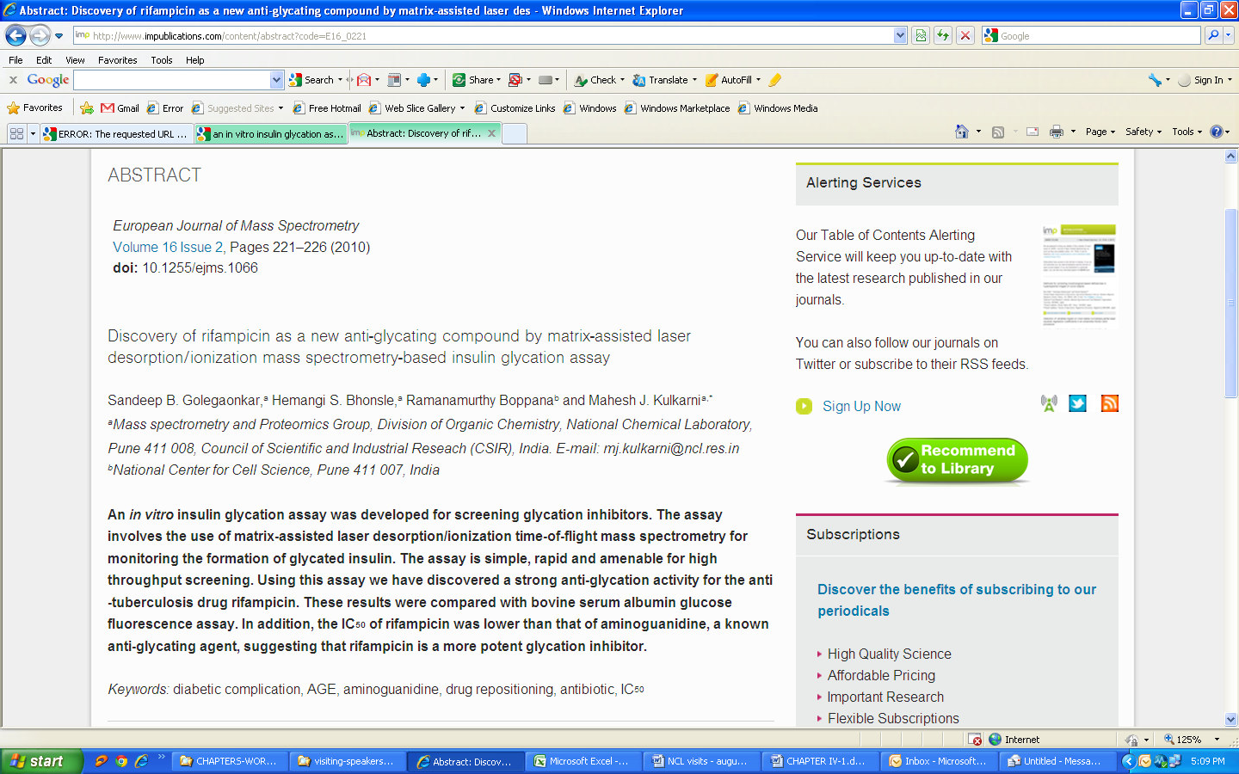

Source: <http://www.ncbi.nlm.nih.gov/pubmed/20212331>

# Results of Study

## Methodology Used for Primary Data Scientific Discovery No. 3

**Water Purifier Developed Using Membrane Based Technology**

### *Problem:*

Though three fourth of the land on earth is occupied by water, there is still an acute shortage of water. It is therefore necessary to conserve water and find means of using it in the most resourceful way. Due to unclean water, typical bacteria borne diseases are caused such as typhoid, dysentery, tuberculosis, cholera, etc. while the virus caused diseases are polio, hepatitis, encephalitis, etc.

### *Background:*

There are several water bodies like mighty rivers, lakes, etc. from where water moves towards the dams carrying with it contaminants that pollute water and get mixed with non potable water. There are still more factors that pollute water on land and make it unsuitable for drinking like throwing of garbage, growth of moss, fungus, excreta etc. It is therefore important and necessary to make the water fit for consumption. In order to reduce water shortage, all of the available water will have to be treated for usage and drinking purposes.

### *About the Existing Technology:*

There are several methods in filtering water for drinking such as chlorination, ultraviolet (UV), and ozone filtration. Undesirable species in water like worms, spores, bacteria, viruses, etc. are removed with the help of using membranes. The membrane has the advantage of physically removing these species.

### *Lessons to learn:*

CSIR-NCL has developed a high-end polymer membrane technology. This is available in the market with the name of ‘Purion’, an ultra high water purifier. It is useful in meeting demands for drinking water in inaccessible and remote areas. The product is available in three commercial

models: Purion XL, Plus and Elite. It filters water in five stages, the last one is the ultra filtration stage, which involves CSIR’s acrylic polymer technology. This technology works in conjunction with hand-pump and does not need electricity for its functioning. Water that is pumped manually passes through these stages in succession and results in ultra pure water.

### *Observation:*

DST (Department of Science and technology) supported this technology and about 40 units have been supplied to NGOs working in public health monitoring for trial and performance evaluation. The technology on non-exclusive basis has been transferred to M/s. Membrane Filters (India) Pvt. Ltd.

### *Method:*

Scientists at National Chemical Laboratory (NCL), Pune have developed the ultrafiltration (UF) membrane with pores that are too small and therefore unable to permit viruses and bacteria. A special additive is used in the dope solution for membrane casting. This controls membrane porosity and offers membranes with desirable pore size. It operates on normal tap water pressure and does not require electricity. The membrane module for household application is 30 cm long with 6.5 cm diameter; while a longer one (1 m long with the same diameter) is suitable for community applications. The water filtration rate for 30 cm module is 1 lit/min, and 3 lit/min at 1 bar pressure for community module. Average life of the membrane is three years depending upon the quality of water.

### *Contribution from CSIR-NCL:*

CSIR-NCL focuses on removal or neutralization of different chemicals and natural minerals etc. from different sources of contaminated water & lands and rendering them fit for different purposes such as human consumption, industrial usage, irrigation etc. CSIR is today involved in multiple and highly intrinsic areas of research, even other than those that pertain drinking water. It has a series of technological solutions and matured technologies for biosalinity, reclamation of saline land, utilisation of brackish water and is successful in reclaiming potable water from saline sea waters. CSIR is moving closer in addressing the scientific challenge and rendering this dream to reality for common man.

### *Publicity:*

1. Sakal dated 31st August, 2012,
2. Sakal Times, 10 Apr 2010, ‘NCL develops new water filtration tech’.
3. Article in Indian Express dated 2nd July, 2008, ‘Coming soon? Drinking water from Pashan lake’.
4. <http://www.expressindia.com/latest-news/coming-soon-drinking-water-from-pashan-> lake/330613/
5. Field Trials were carried out which has been depicted in table 4.5.3.1.

## Figure 4.5.3.1. Sakal dated 31st August, 2012. (Paper Clipping – Popularisation Purpose)

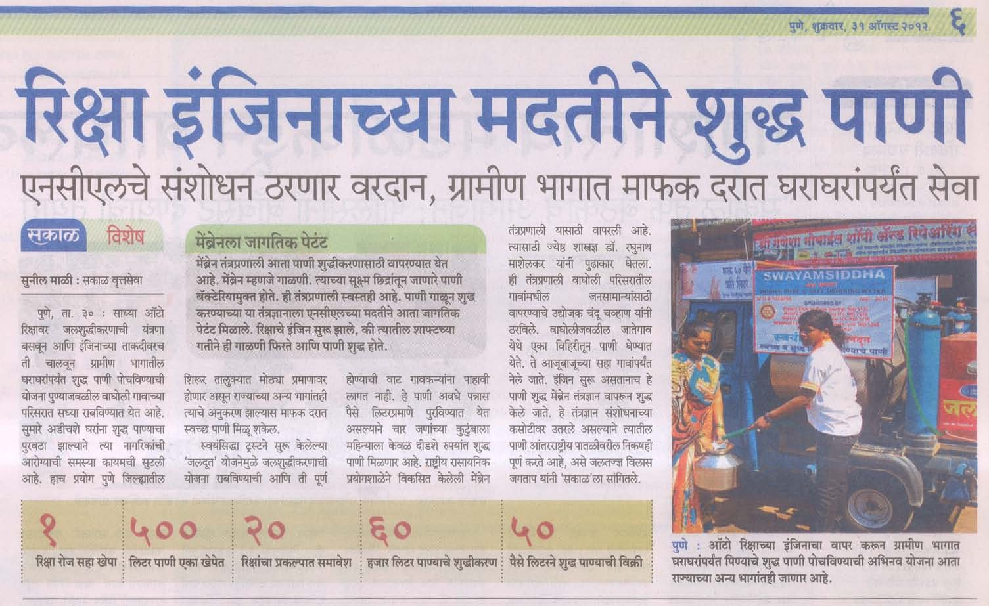

**Figure 4.5.3.2. Sakal dated 10th April, 2010. (Paper Clipping – Popularisation Purpose)**

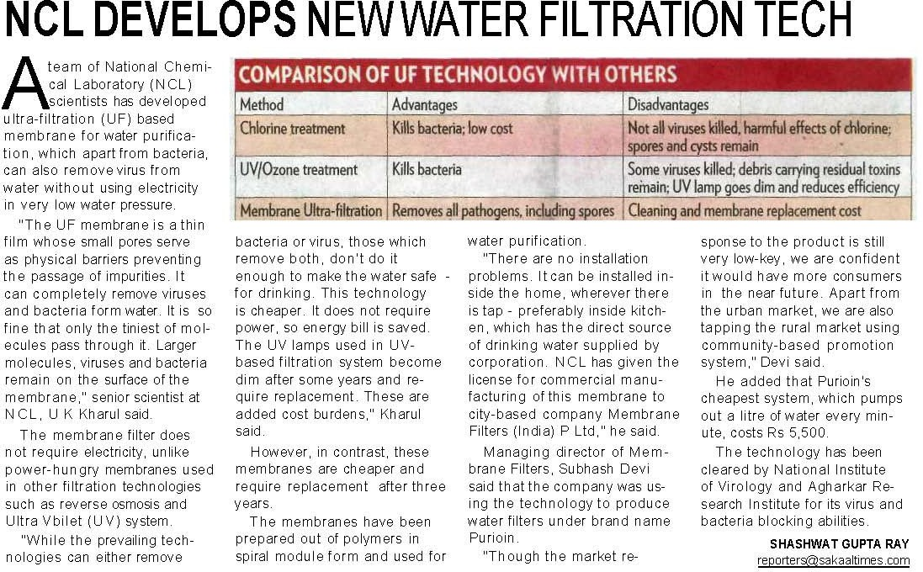

**Figure 4.5.3.3. Sakal dated 2nd July, 2008. (Paper Clipping – Popularisation Purpose)**

**Figure 4.5.3.4.**

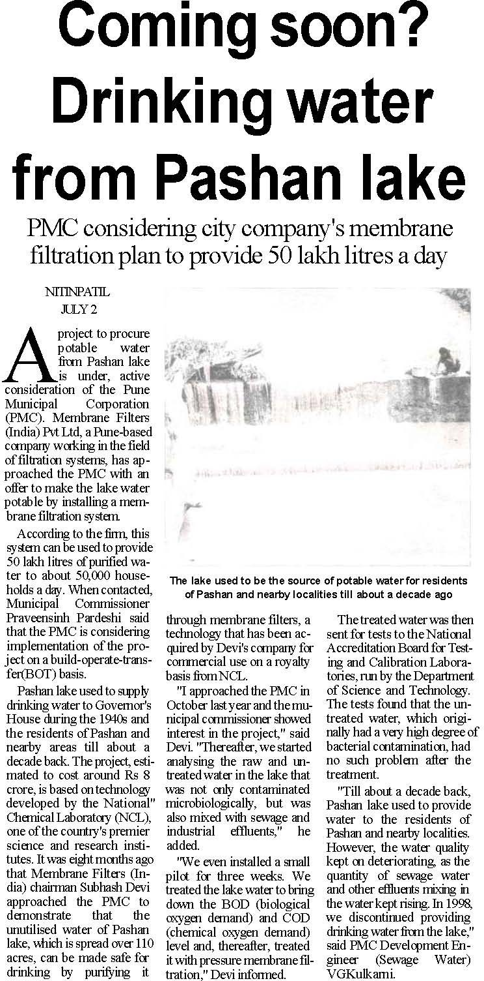

**Times of India dated 12th September, 2012.**

**(Paper Clipping – Popularisati on Purpose)**

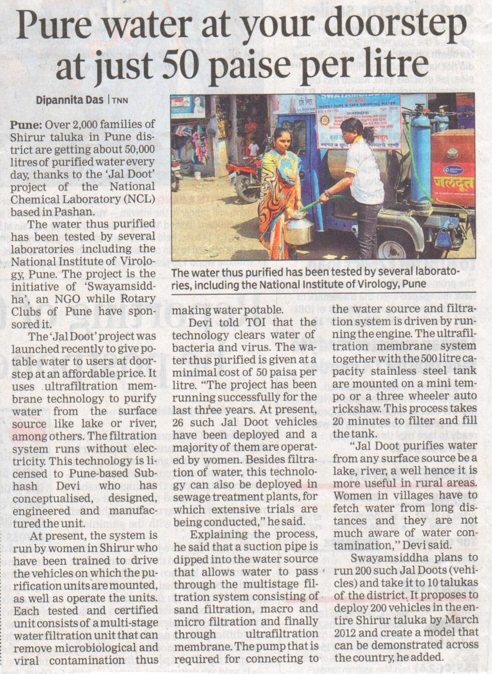

**Table 4.5.3.1 – FIELD TRIALS**

Safe drinking water for cyclone affected people in Orissa was delivered immediately after the calamity. Fifteen hand pump based units for producing water purification were air-lifted to cyclone- affected areas near Paradip in Orissa on 13th November, 1999. This technology has proven to be highly appropriate for the extreme circumstances in several devastated regions where potable water quality was found to be very poor and electrical supply was unavailable. The units are portable and thus could be lifted to the inner areas. NCL representatives visited these places periodically in order to monitor the performance of the units. The quality check, done by NEERI, Nagpur; revealed absence of bacterial count in permeate. Research on improvement in the performance of the membrane (essentially the throughput of water) is in progress.

Source: Discussions in a meeting with Dr. Kharul, Senior Scientist, CSIR-NCL, information is available on NCL website (www.ncl-india.org).

* For further details kindly contact Dr. Kharul at [uk.kharul@ncl.res.in.](mailto:uk.kharul@ncl.res.in)

### *References:*

1. Lohokare, H. R., Bhole, Y. S. and Kharul, U. K. (2006), Effect of support material on ultrafiltration membrane performance. J. Appl. Polym. Sci., 99: 3389–3395.
2. Lohokare, H. R., Kumbharkar, S. C., Bhole, Y. S. and Kharul, U. K. (2006), Surface modification of polyacrylonitrile based ultrafiltration membrane. J. Appl. Polym. Sci., 101: 4378–4385.
3. <http://www.nclinnovations.org/technology.php>
4. Personal Discussion with the Dr. Kharul, Scientist, CSIR-NCL.

### *Original article is below:*

**Figure 4.5.3.2. Original Snapshot of a Typical Research Paper.**

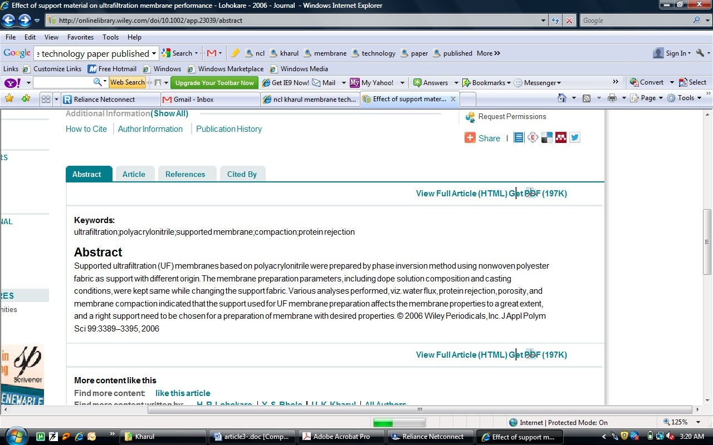

Source: <http://onlinelibrary.wiley.com/doi/10.1002/app.23039/full>

# Results of Study

## Methodology Used for Primary Data Scientific Discovery No. 4

**Nano-Curcumin pills to treat cronic ailments**

### *Problem:*

To find out if nano curcumin pills can treat cronic ailments.

### *Background:*

Gellan gum is a high molecular weight polysaccharide (i.e., complex sugar) gum produced as a fermentation product by a pure culture of the microbe Sphingomonas elodea (formerly known as ‘Pseudomonas elodea’). Its structure consists of four linked monosaccharides (i.e., simple sugars), including one molecule of rhamnose (a sugar found in various plants), one molecule of glucuronic acid (an oxidized glucose molecule), and two molecules of glucose (a component of sucrose, which is common sugar). The exact molecular formula of gellan gum may vary slightly e.g., depending on the degree to which the glucuronic acid is neutralized with various salts.

### *About the Existing Technology:*

“Gellan Gum”, (GG) widely used in food and confectionary industry as a thickening and gelling agent. Because of this property, it has been used as a reducing and stabilizing agent for the synthesis of gold nanoparticles. These nanoparticles display greater stability to electrolyte addition and pH changes relative to the traditional citrate and borohydride reduced nanoparticles. Subsequently these have been used to load anthracycline ring (anthracyclines (or anthracycline antibiotics) are a class of drugs used in cancer chemotherapy, see wikipedia)) antibiotic doxorubicin hydrochloride (an antibiotic used as an anticancer drug). The drug loaded on these nanoparticles showed enhanced cytotoxic effects on human glioma (Glioma is a tumor in the glial cells (Glial cells lines our central canal of the spinal cord to the brain. Types of glial cells are radial glia, schwann cells, oligodenrcytes and astrocytes). These cells are located in the Central Nervous System, also known as the CNS. A glioma is usually considered as a brain tumor that usually becomes cancerous) cell lines.

### *Lessons to learn:*

In this study the team took advantage of the reducing and stabilizing properties of the GG for the synthesis of gold nanoparticles.

### *Observation:*

Nanoparticle based drug delivery systems are considered a good alternative because nanoparticles showed its ability to cross BBB effectively. In this background, it was found that gum loaded nanoparticles possessed additional advantageous as reported that BBB contains glucose receptors and thus the nanoparticles stabilized by GG with many sugar moieties may be favored to cross the BBB.

### *Method:*

The activity of nanoparticles on gial cells was assessed, the drug that was loaded on the nanoparticles showed enhanced cytotoxic effect as compared to pure drug taken at same concentrations present on the nanoparticle and also stayed on the surface showing its effectiveness for a longer period of time. This was observed and stated by Dr. Anjali Shiras from National Centre for Cell Science (NCCS), where she assessed, the activity of nanoparticles.

### *Contribution from CSIR-NCL:*

Anticancer drugs generally face a big problem against brain tumors because, the Blood Brain Barrier (BBB) does not allow the drugs to cross it and as a result, delivery to the tumor site is blocked. Nanoparticle based drug delivery systems are considered a good alternative because nanoparticles showed its ability to cross BBB effectively. In this background, it was found that gum loaded nanoparticles possessed additional advantageous as reported that BBB contains glucose receptors and thus the nanoparticles stabilized by GG with many sugar moieties may be favored to cross the BBB. While the present work showed the effective anti cancerous activity of drug loaded-GG stabilized-Gold nanoparticles in vitro future studies NCL alongwith NCCS is currently actively pursuing the *in vivo* studies.

* + - * + For further details contact Dr. B. L. V. Prasad at [pl.bhagavatula@ncl.res.in.](mailto:pl.bhagavatula@ncl.res.in)

### *Publicity:*

1. The work has appeared on the cover page of the December 2008 issue of “Chemistry: A European Journal” (see figure 4.5.4.1.**)**
2. Newspaper coverage, refer July 17, 2008, Medical Research (see figure 4.5.4.2.).

## Figure 4.5.4.1. Article appearing on the Journal Cover page



**Figure 4.5.4.2. Article dated July 17, 2008. (Paper clipping for science popularization purpose)**

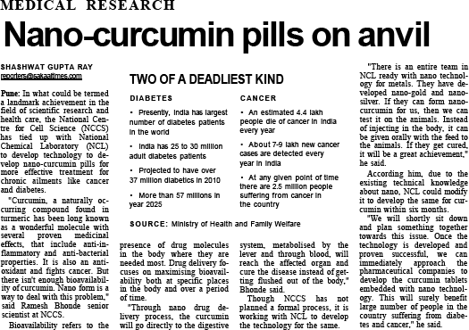

**4.5.4. 9. *References:***

1. Dhar, S., Reddy, E. Maheswara., Shiras, A., Pokharkar, V. and Prasad, B. L. V. (2008), Natural Gum Reduced/Stabilized Gold Nanoparticles for Drug Delivery Formulations. Chem. Eur. J., 14: 10244–10250.

(Funded by DST, New Delhi, DST-Unit on Nano Science and Technology (DST-UNANST)

1. Technical Evaluation Report, Compiled by ICF Consulting for the USDA National Organic Program, (2006), pp.1-6)
2. <http://www.nclinnovations.org/technology.php>

### 4.5.4.6. *Original article is below: (Snapshot of original article)*

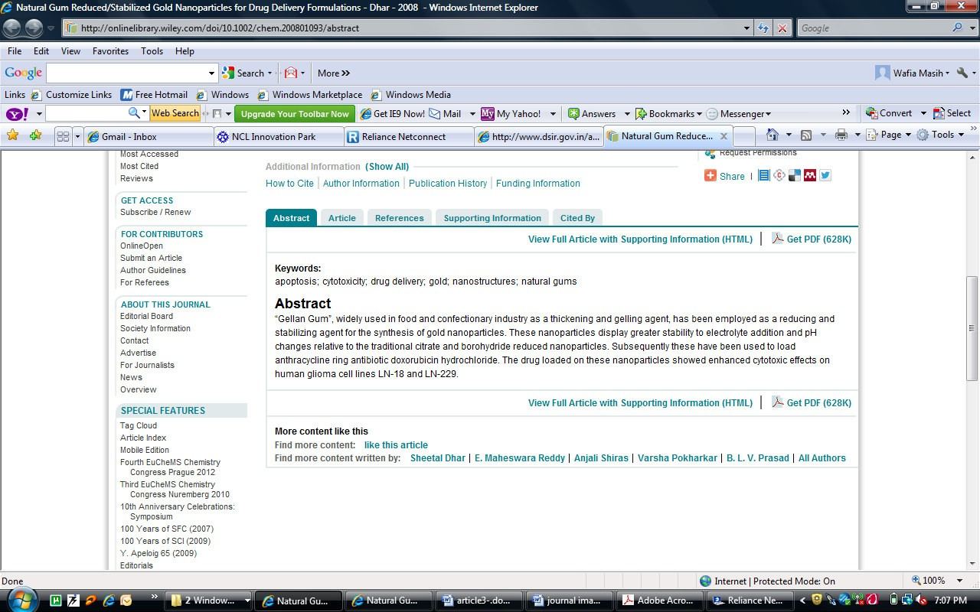

Source: <http://onlinelibrary.wiley.com/doi/10.1002/chem.200801093/full>

# Results of Study

## Methodology Used for Primary Data Scientific Discovery No. 5

**Development of drug molecules for targeting HIV with protease inhibitor**

### *Problem:*

HIV is a major human health concern throughout the world. HIV is a virus that goes through many steps during its life cycle. Once HIV infects a human cell, the virus uses proteins and chemicals inside that cell to make more copies of it. Protease is a chemical, known as an enzyme that HIV needs in order to make new viruses. Protease inhibitors (PIs) block the protease enzyme. When protease is blocked, HIV makes copies of itself that can't infect new cells. Studies have shown that protease inhibitors can reduce the amount of virus in the blood.

### *Background:*

When a person suffers from AIDS (Acquired Immunodeficiency Syndrome) also known as HIV (Human Immunodeficiency Virus) his body undergoes a condition in which his body’s specific defense mechanisms stop functioning. This occurs due to the gradual loss of immune cell function. This happens because the cells of the body start allowing interference by other infectious agents, and the body to fight infection reduces. The HIV virus infects the white blood cells also known as macrophages, dendritic cells and T-helper cells.

### *About the Existing Technology:*

There is no definitive cure for AIDS and therefore it is a serious public health problem especially in developing countries due to the high cost of current drugs where only a small percentage of infected people benefit from the available treatments. The therapeutic strategies include inhibitors directed at various stages in the life cycle of HIV.

### *Lessons to learn:*

Attempts for eradication of human immunodeficiency virus (HIV) resulted in discovery of powerful antiviral compounds. The highly active antiretroviral therapy (HAART) has showed significant improvements in the disease state therefore HAART is also called as Potent Antiretroviral Therapy (PART). Drugs help in control of viral replication but eradicating the same is being researched at.

### *Observation:*

The virus persists even after long periods of treatment due to the presence of cellular reservoirs. These contain latent viruses which are found to be capable of producing new infectious particles. Patients getting treatment stop mid way due to the onset of side effects and viral resistance often develops, making one or more of the drugs ineffective. It is clear that HIV virus replicates itself in the human body, hence it is important that drugs are developed that can treat the virus at various stages.

### *Method:*

Dr. Mala Rao and her research team at National Chemical Laboratory (NCL), Pune have isolated an extremophilic Bacillus sp., which produces an aspartic protease inhibitor (ATBI). ATBI has been characterized for its inhibition against recombinant HIV-1 protease, pepsin, and the protease from the fungus named Aspergillus saitoi. CSIR-NCL scientists also isolated and purified several other protease inhibitors from different natural sources. Currently, ATBI and the other purified inhibitors are being studied as a lead molecule for designing potent inhibitors.

## Figure 4.5.5.1.Life Cycle of HIV

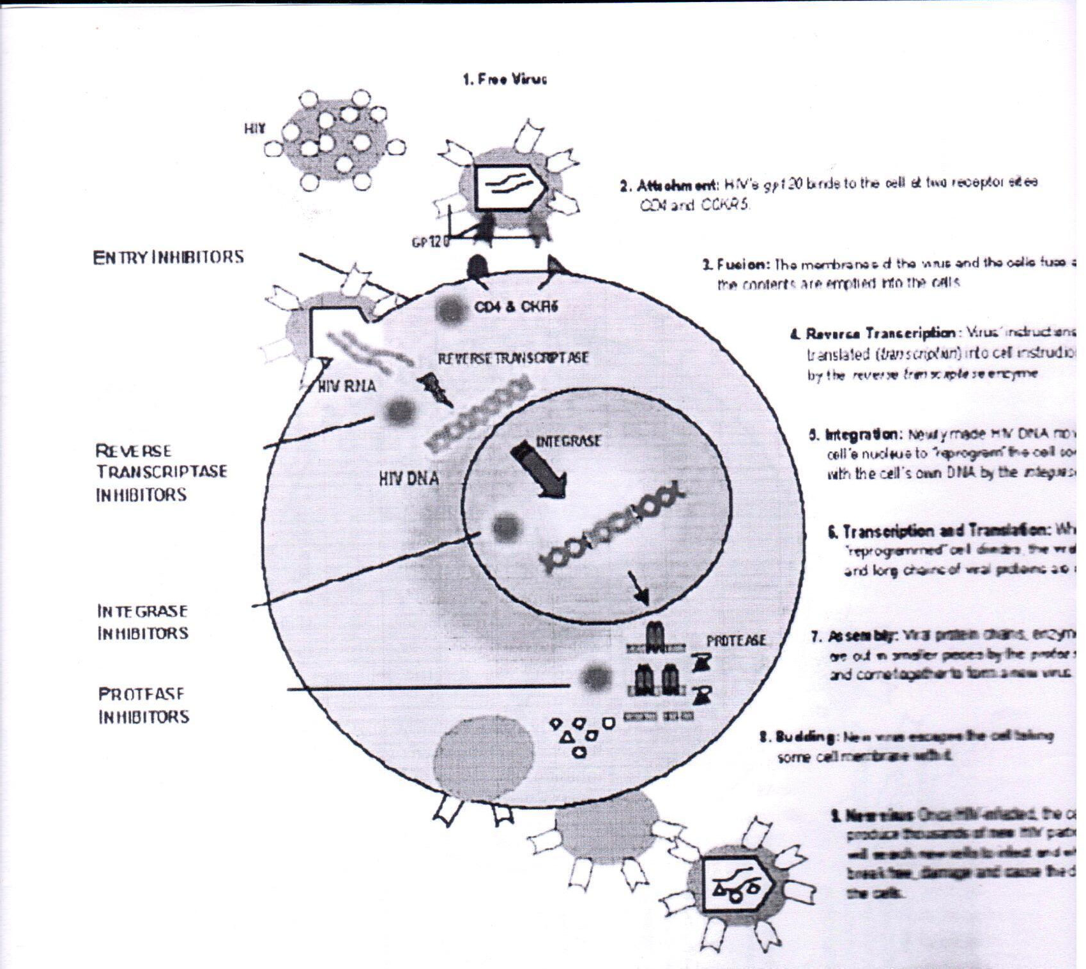

Source: Advanced Biotech, November 2004, page 14.

### *Contribution from CSIR-NCL:*

The first biologically derived molecule that inhibits HIV-1 Protease has been isolated by the team at NCL led by Dr. Mala Rao. This enzyme is responsible for the multiplication of the AIDS causing virus. The molecules were isolated from a robust microbe that thrives in high temperatures and alkaline conditions in a hot spring at Vajreshwari, in Thane district. The effort is viewed as a new approach to isolation of rare bio-molecules.

### *Publicity:*

1. The news article appeared on 18th May, 2005.
2. The work has been published in ‘News India’ a supplementary of Nature for the subscribers of Nature in India.

## Figure 4.5.5.1. Article dated 18th May, 2005. (Paper clipping for science popularization purpose)

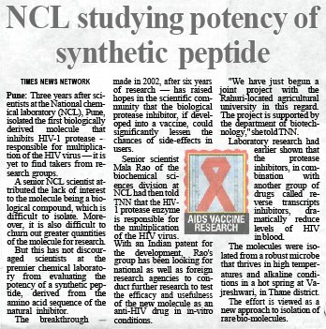

### *References:*

1. Chandravanu Dash and Mala Rao (2001), Interactions of a Novel Inhibitor from an Extremophilic *Bacillus* sp.with HIV-1 Protease, The Journal Of Biological Chemistry, Vol. 276, No. 4, Issue of January 26, pp. 2487–2493, 2001.
2. Dash, C, Ahmad, A, Nath, D and Rao M, (2008), Antimicrob. Agents Chemother, vol. 48, No. 7, pp. 2017
3. <http://www.nclinnovations.org/technology.php>
4. Personal Discussion with Dr. Mala Rao
   * For further details contact Dr. Mala Rao at [mb.rao@ncl.res.in](mailto:mb.rao@ncl.res.in) or Dr. Absar Ahmed at [a.ahmad@ncl.res.in](mailto:a.ahmad@ncl.res.in)

### *Original article is below: (snapshot of original article).*

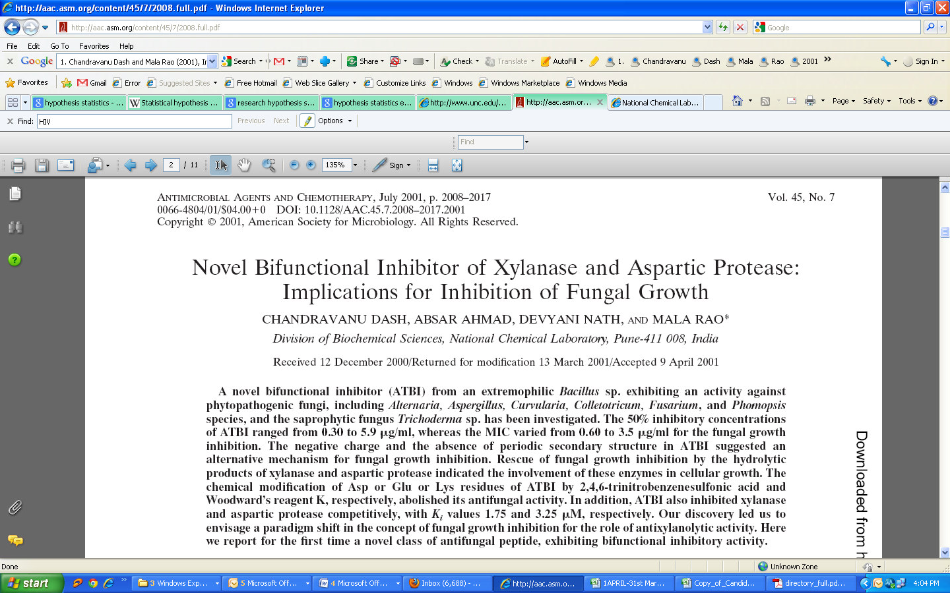

Source: <http://www.ncbi.nlm.nih.gov/pmc/articles/PMC90593/pdf/ac002008.pdf>

# Results of Study

## Methodology Used for Primary Data Scientific Discovery No. 6

**To make the cuticle of insects soft for killing fungi**

### *Problem:*

It is often found that insects, mites, pests infect our food, crops, seeds and fiber. Efforts from various researchers for finding out methods to eradicate them are being sought. One such effort for pests found on agricultural crops is being researched by scientists of CSIR-NCL.

### *Background:*

CSIR-NCL Scientists have found out that certain enzymes have the potential to soften the cell walls (also known as cuticle) of pests. These enzymes could help in softening the cell walls of a certain class of pesticides called the mycopesticides. Any pesticide that contains live fungi is called Mycopesticides.

### *About the Existing Technology:*

Synthetic chemicals are highly effective pesticides, but excessive use of these has made pests develop resistance towards the pesticides and the synthetic pesticides are also a threat to human health and the environment. Hence it has become important to find alternate routes to control the insect menace especially in open fields for agricultural crops.

### *Lessons to learn:*

Chitin deacytylase (CDA) protects the fungi from attack by insect enzymes. CDA is now being explored as a component of integrated pest management for faster killing of the insects when used with myco-pesticides. CSIR-NCL is now working towards cost-effective production of the CDA enzyme.

### *Observation:*

An NCL team led by Dr. M.V. Deshpande has demonstrated that certain enzymes in conjunction with the fungi form a highly effective integrated formulation to kill pests. For example, in lab tests, use of the enzyme with Metarhizium anisopliae, (a fungus) used against a pest called the gram pod borer (Helicoverpa armigera) took less than three days to eliminate the pest.

### *Method:*

The fungi produce dry spores. These stick to the body of the insect. Once it gets attached to the body of the insect, the fungal spores are found to produce filaments called hyphae that penetrate the body of the insect. These filaments then multiply and poison the pest. Typically, the fungal filaments enter the insect body through wounds or joints which lie between segments of the insect body or via its sense organs. The main barrier in the penetration process is the hard skin (cuticle) of the insect that is composed of a hard polymer called chitin. Therefore, if the insect cuticle can softened, the pest can be killed faster by fungal filaments.

### *Contribution from CSIR-NCL:*

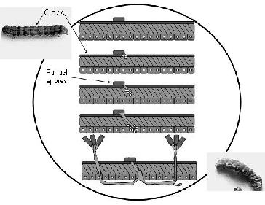The breakthrough made by CSIR-NCL Scientist, Dr Deshpande was to recognize and prove that a particular enzyme called chitin deacytylase (CDA) converts chitin, the hard insect skin polymer into a soft polymer called chitosan. Once the cuticle is softened it is easily penetrated by fungal filaments.

Source: <http://www.nclinnovations.org/pdfs/techmaking/ncl/2004mar19-softening-insect-> cellwalls.pdf

* For further details kindly contact Dr. Mukund Deshpande at [mv.deshpande@ncl.res.in.](mailto:mv.deshpande@ncl.res.in)

### *4.5.6.7. Publicity:*

This work has been featured in “News India”, June 2004, a supplementary of Nature, published in India.

## Figure 4.5.6.1. Article appeared in “News India” dated June 2004 (paper clipping for popularization purpose)

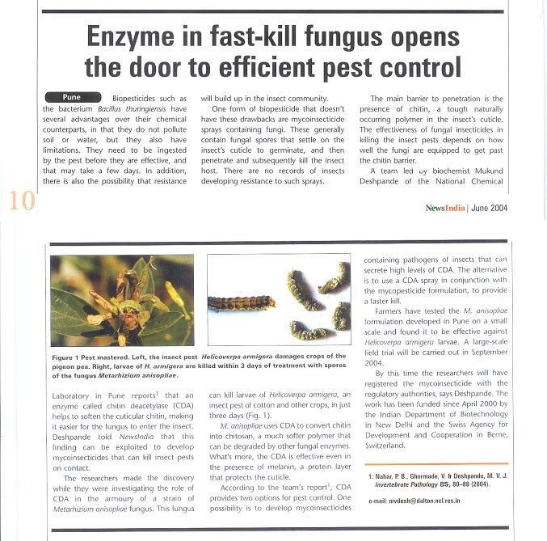

### *References:*

* + - * 1. The extracellular constitutive production of chitin deacetylase in Metarhizium anisopliae: possible edge to entomopathogenic fungi in the biological control of insect pests, Pallavi Nahar, Vandana Ghormade and Mukund V. Deshpande, Journal of Invertebrate Pathology, Volume 85, Issue 2, February 2004, Pages 80-88.
        2. Comparative Evaluation of Indigenous Fungal Isolates, Metarhizium anisopliae M34412, Beauveria bassiana B3301 and Nomuraea rileyi N812 for the Control of Helicoverpa armigera (Hub.) on Chickpea, Pallavi Nahar, Mahesh Kulye, Priya Yadav, Mounir Hassan, Urs Tuor, Siegfried Keller and M.V. Deshpande, Journal of Mycology and Plant Pathology, Volume 33, Issue 3, 2003, Pages 372-377.
        3. Davis, R., (2003), ‘INSECT PESTS/Insects and Related Pests’, Pest Management Consultants and Associates, Savannah, GA, USA, Elsevier Science td.
        4. [http://www.nclinnovations.org](http://www.nclinnovations.org/)
* Personal Discussions with Dr. Mukund V Deshpande at CSIR-NCL.

**Figure 4.5.6.2. *Original article is below: (snapshot of original article).***

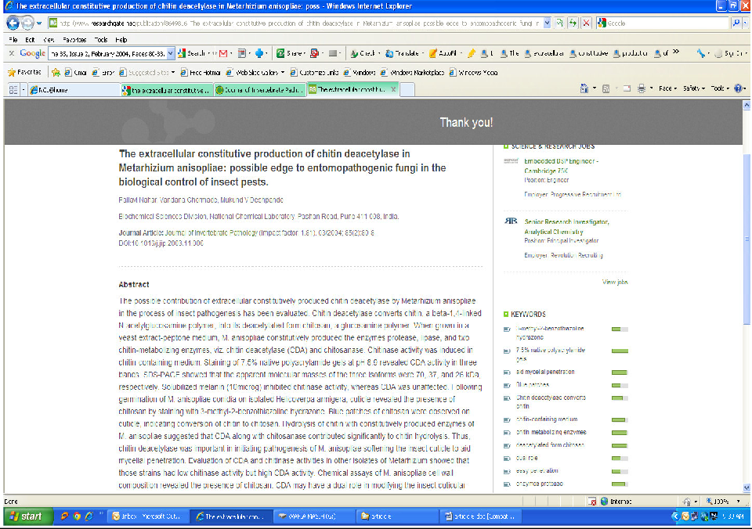

<http://www.sciencedirect.com/science/article/pii/S0022201103001733>

# Results of Study

## Methodology Used for Primary Data Scientific Discovery No. 7

**Enzyme Based Method to Remove Hair from Leather for Application Purpose**

### *Problem:*

Pollution is the main problem in the process for extracting leather. Hair is not completely removed and whatever is removed causes pollution and generates approximately 300,000 tonnes of solid wastes per year.

### *Background:*

Though leather is a foreign exchange earner, the process of extracting leather is highly polluting and involves several steps to remove hair. Because of this, many tanneries have closed down.

### *About the Existing Technology:*

Earlier chemical technologies were used to remove hair. This generated solid wastes due to loss of hair and poor quality of leather. The hair was not completely removed from the roots.

### *Lessons to learn:*

Researchers from CSIR-NCL are finding out the possibility of licensing the technology and discussions for the same are in progress. Two US patents No 6777219 and No 7186546 were granted for production and application of protease. In addition two more functional enzymes for dehairing have been developed at CSIR-NCL. Complete evaluations in the tanneries upto the pilot scale have been carried out.

### *Observation:*

Microbial enzymes derived from bacteria have gained commercial interest because they are easily produced by submerged cultivation having properties such as high yield of enzyme, short, duration for production, and easy recovery of the enzyme.

### *Method:*

Different methods such as the paint, paste, dip etc. are used for different applications of leather extraction. Penetration of enzyme is difficult depending upon the skin texture. The enzyme is applied and allowed to penetrate the hair. This is then kept in room temperature for about 12 to 14 hours and at the end of the application the hair is removed manually with minimum effort.

### *Contribution from CSIR-NCL:*

The enzyme has been scaled up at pilot level and trials have been carried out in commercial tanneries. The method used is totally synthetic. There are no chemicals added in the dehairing process.

### *Publicity:*

The article appears on Advanced Biotech, September, 2005 issue.

## Figure 4.5.7.1. Article appeared in Indian Express dated 5th July, 2007 (paper clipping for popularization purpose)

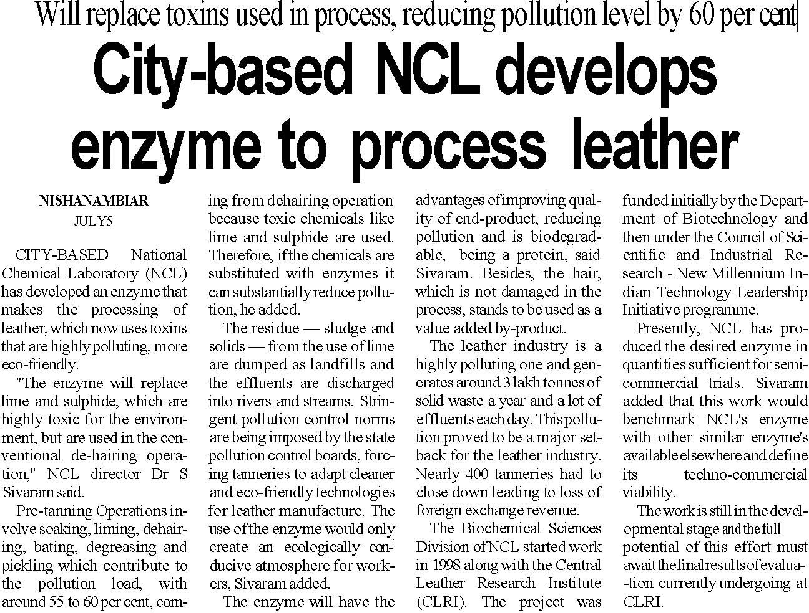

### *References:*

1. A. Amudeswari, P. Saravanan, J. Raghava Rao and T. Ramasami, (2009) ‘Leather Bioprocessing: A Greener Finish’, Biotech News, 4:7, February, page 4.
2. Two US patents No 6777219 and No 7186546 were granted for production and application of protease.
3. [www.ncl-india.org](http://www.ncl-india.org/)
4. Personal Discussion with Dr. Mrs. S. R. Thengane
   * For further details contact [sr.thengane@ncl.res.in](mailto:sr.thengane@ncl.res.in) or [srthengane@gmail.com](mailto:srthengane@gmail.com)

**Figure 4.5.7.2. *Original article is below: (snapshot of original article).***

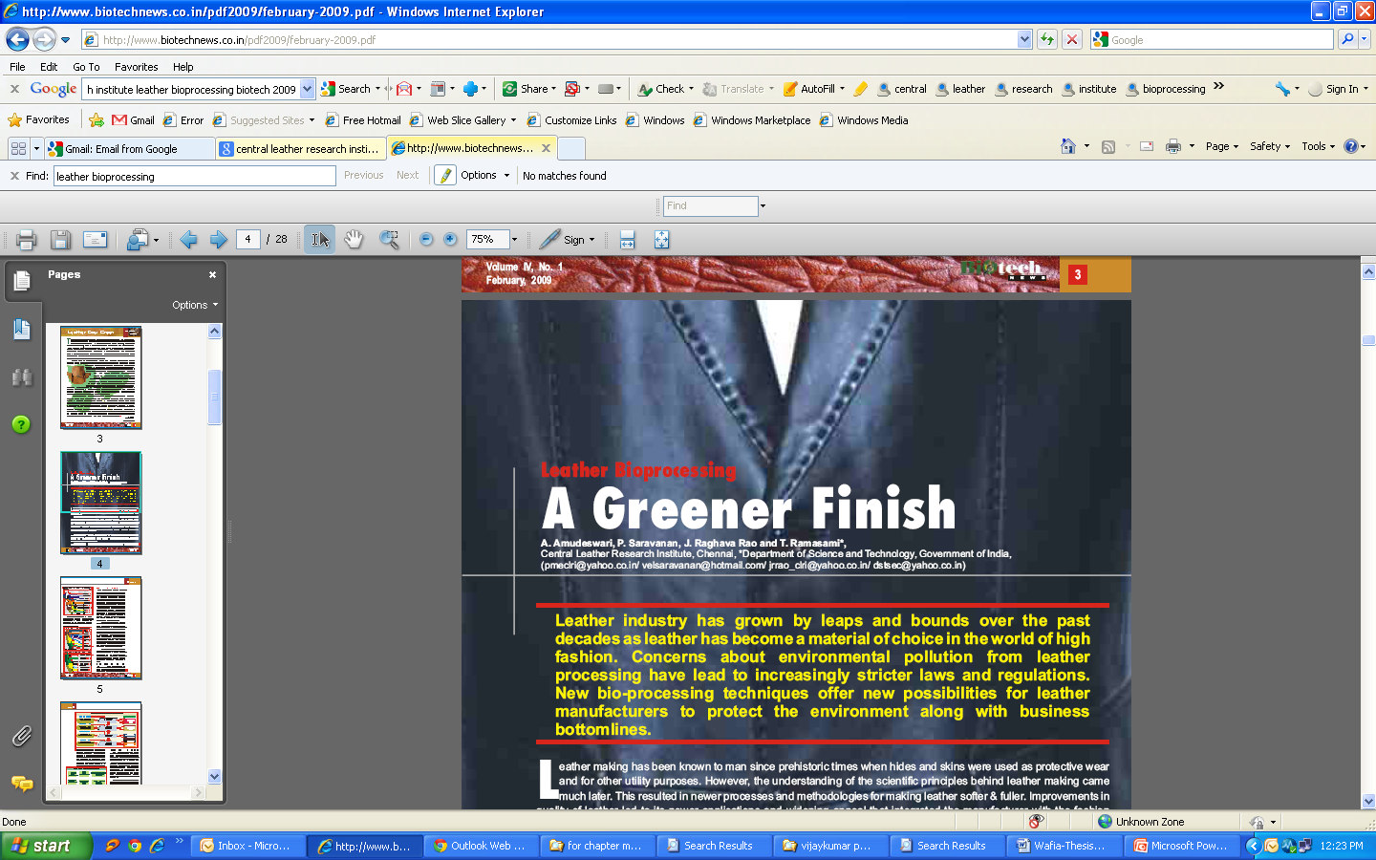

Source: <http://www.biotechnews.co.in/pdf2009/february-2009.pdf>

# Results of Study

## Methodology Used for Primary Data Scientific Discovery No. 8

**Bacterial Enzymes Can Replace Stonewashing Demin Jeans**

### *Problem:*

Jeans are made out of denim fabric. The latest fashion is to wear jeans which appear faded. The method used for making jeans appear faded was by using the process of pumice stone. In this method the freshly dyed denim fabric was tumbled with pumice stones to give a faded appearance. This had the disadvantage of waste production and environmental issues.

### *Background:*

Stone washing is a process that is used to give denim a worn out look. It also increases the denim's softness and flexibility. Stone washed jeans have been popular for quite some time. The late 1960's popularized the worn out look for jeans.

### *About the Existing Technology:*

For giving a faded appearance to the denim jeans they are washed with pumice stones. In order to stone wash jeans, the original way, they are washed with pumice stones. This process scraps the surface layer of the jeans and threads from the fabric are emerged and become visible. The jeans therefore look worn out.

### *Lessons to learn:*

Cellulase enzyme treatment has been promoted to avoid the machine induced severe wear and loss of tensile strength during denim processing. The minimization of water contamination, clean-up effort and substantial reduction in use of toxic chemicals are areas where enzymes have potential to play a significant role in decreasing the pollution.

### *Observation:*

Enzymatic treatment of fabric is an ecofriendly process and allows up to 50% higher jeans load and yields the desired look and a softer finish. Cellulases are also used to improve the appearance of cellulosic fabric by removing fuzz fiber and pills from the surface, reducing pilling propensity, or delivering softening benefits. The damage caused to the machine wear is negligible and there is no clogging of outlet of washing machine by sand due to eroding of pumice stone in the traditional process.

The enzyme will develop an eco-friendly technology due to its compatibility with other chemical processes. It is found that there is an increase in production since seven litres of cellulase can wash 3 - 4 kg of denim.

### *Method:*

Scientists from NCL discovered the enzyme used for giving denim a stone wash effect from bacteria called ‘alkalothermophilic thermomonospora’, this is found to grow in extreme conditions. The enzyme was produced by this bacteria and it was applied instead of pumice stone.

### *Contribution from CSIR-NCL:*

The enzyme from bacteria promises to develop an eco-friendly technology and is also found to be compatible with other chemical processes. This has resulted in an increase in production namely seven litres of cellulase can wash 3-4 kg of denim. The CSIR-NCL scientists demonstrated the application of these cellulases for biofinishing of denims in collaboration with Ahmedabad Textile Industry’s Research Association (ATIRA). These cellulases were effective in biofinishing of denim with respect to the removal of hairiness with marginal total weight loss, increasing softness of the fabric and abrasive activity with low backstaining.

### *Publicity:*

1. <http://www.nclinnovations.org/technology.php>
2. The article appeared in ‘fibre2fashion’ online on January 31, 2007 , ‘Enzymes instead of pumice stone for faded denim’, see excerpts in Table 4.5.8.1. below.
3. <http://www.fibre2fashion.com/news/companynews/dystar/newsdetails.aspx?news_id=29925>
4. [http://www.ncl-india.org/ResearchGroups/searchtemplate.jsp?se=85&mid=3&sid=7](http://www.ncl-india.org/ResearchGroups/searchtemplate.jsp?se=85&amp;mid=3&amp;sid=7)
5. <http://www.fibre2fashion.com/news/fashionnews/newsdetails.aspx?news_id=29925>
   * For further details contact Dr. Mala Rao at [mb.rao@ncl.res.in](mailto:mb.rao@ncl.res.in)

## Table 4.5.8.1. Article appeared in ‘fibre2fashion’ online on January 31, 2007, ‘Enzymes instead of pumice stone for faded denim’.

Enzymes instead of pumice stone for faded denim January 31, 2007 (India)

Use of pumice stone to get the stonewash effect on denims may get replaced and now an enzyme may equally do the job well.This enzyme which is capable of growing even in extreme conditions is obtained from a bacteria —alkalothermophilic Thermomonospora. Pune-based scientists of National Chemical Laboratory (NCL) have found this enzyme in soil at Barabanki in Uttar Pradesh. Using cellulase to wash denim is a standard eco-friendly technique to achieve softness for cotton fabrics and denims, says a report published in Wiley InterScience Journal on September 1, 2006 after conclusion of tests at Ahmedabad Textile Industry Research Association.Cellulase while reducing hairiness in fabric, made it lighter, softer giving the stonewashed effect, whereas pumice stone produces severe wear and tear which not only weakens the fabric but also clogs outlet of the washing machine, according to NCL scientists. NCL scientists say the enzyme will develop an eco-friendly technology and are compatible with other chemical processes increasing production as seven litres of cellulase can wash 3-4 kg of denim.Dr Mala Rao along with her team from NCL has worked on this project for over five years with trials underway since last two years. It was funded and supported by department of biotechnology, Government of India, New Delhi, DST, TIFAC.

**Figure 4.5.8.1. Article appeared in Times of India, Delhi, dated 5th February, 2007 (paper clipping for popularization purpose)**

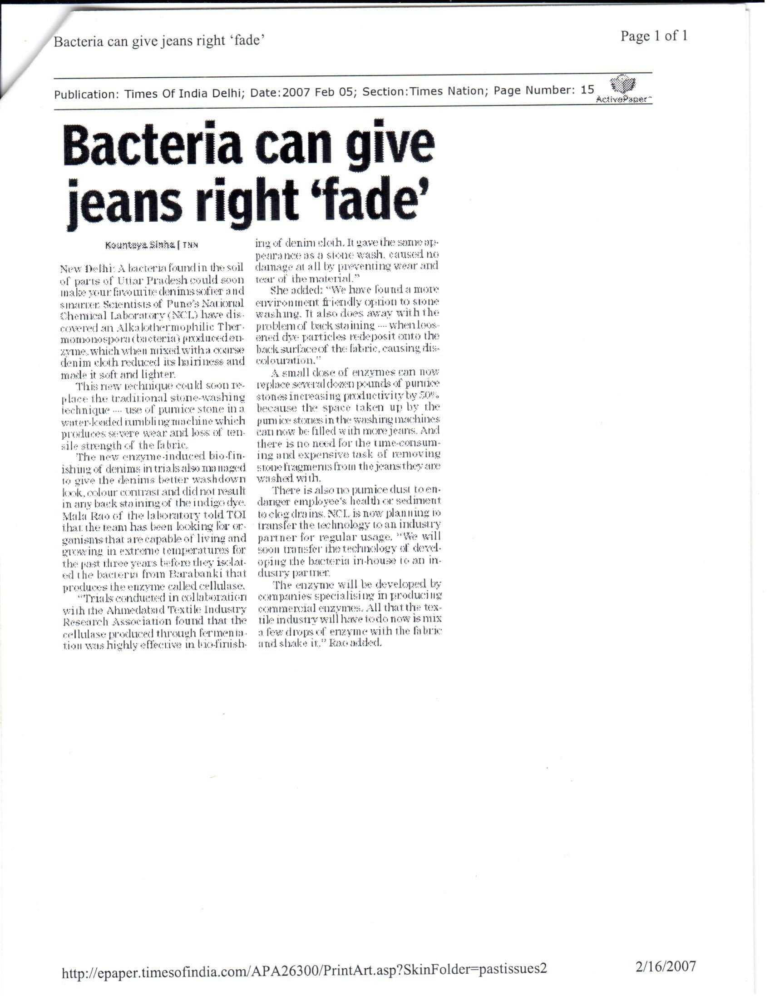

### *4.5.8.9. References:*

1. <http://cotton.missouri.edu/Classroom-StoneWash.html>
2. Ramakrishnan Anish, et. al.,‘Application of Cellulases From an Alkalothermophilic Thermomonospora sp. In Biopolishing of Denims’, (2007), Biotechnology and Bioengineering, Vol. 96, No. 1, January 1, pp. 48-56.
3. Indian patent no. 245202, A Process For Biofinishing of Denims In Textile Industry.
4. Report published in Wiley InterScience Journal on September 1, 2006
5. [http://www.](http://www/) jeansinfo.org
   * + Personal Discussions with Dr. Mala Rao

**Figure 4.5.8.2. *Original article is below: (snapshot of original article).***

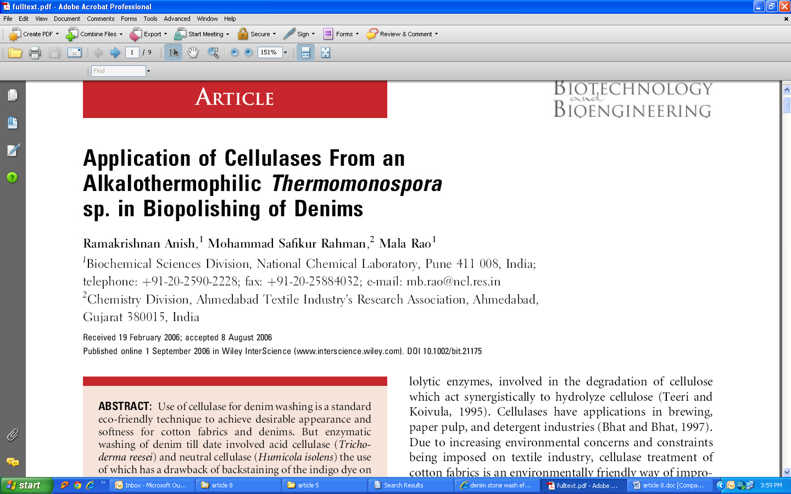

Source: <http://link.springer.com/article/10.1007%2Fs10295-011-0968-x?LI=true>

# Results of Study

## Methodology Used for Primary Data Scientific Discovery No. 9

**Energy Crisis Solution by Converting Methane and Methanol into Gasoline**

### *Problem:*

Due to the increased energy demand world-over, efforts were made to develop alternative methods for the conversion of methane (a main constituent of natural gas and biogas) into value- added products like the liquid hydrocarbon fuels. As methane is one of the key greenhouse gases responsible for global warming, the current industrial practice of emission and or flaring of produced methane are likely to become difficult in the future. Therefore in remote places the methane that is produced must be converted into energy sources like liquid hydrocarbon fuels.

### *Background:*

Scientists from CSIR-NCL have successfully converted methane and methanol into gasoline and have also received a US patent in April 2006.

### *About the Existing Technology:*

The existing or known route for transforming methane into liquid hydrocarbons is: methane – syngas – gasoline. This is based on: methanol – to – gasoline (MTG) process. The researchers at CSIR-NCL have achieved a non-oxidative process by activation of methane gas and methanol. The existing route is highly exothermic, the heat evolved is difficult to remove because of which the process is becomes uncontrollable and also causes toxic benzene formation whereas the process suggested by CSIR-NCL is carried out under normal conditions without heat being evolved and there is no formation of toxic benzene. Thus, NCL process is not only energy efficient, but also thermo-neutral.

### *Lessons to learn:*

The process would help largely to tap the vast unused reserves of naturally available methane gas, which is considered to be one of the key greenhouse gases responsible for global warming.

### *Observation:*

Methane is converted at low temperature (600 °C) over bifunctional zeolite catalysts. There are many applications of this conversion one of which include using the gasoline to run vehicles. The scientist at NCL tried to transform methane into liquid hydrocarbons but did not succeed in getting the desired results.

### *Method:*

In brief, the formation of carbon monoxide in the methanol conversion in the presence or absence of methane was tested and found to be negligible. Formation of carbon monoxide was detected upon passing a mixture of methane and steam over the bifunctional zeolite catalyst at 550°C and it was found that there was no formation of carbon monoxide. The activation and conversion of methane in the process was confirmed by using carbon-labeled methanol and analysis of the aromatic hydrocarbons.

### *Contribution from CSIR-NCL:*

Scientists from CSIR-NCL could tap vast unused reserves of naturally available methane gas through their process for alternative energy and this gas is also considered as one of the greenhouse gases responsible for global warming. Many applications of this conversion process have been found and the most important is that gasoline can be used to run vehicles.

* + - * + For further details kindly contact Dr. V. R. Choudhary or Dr. Shafeeq Mulla at [sa.mulla@ncl.res.in.](mailto:sa.mulla@ncl.res.in)

### *Publicity:*

1. The article for publicity appeared in Times of India dated 30th November, 2006.

## Figure 4.5.9.1. Article appeared in Times of India dated November 2006, the below figure is an extension of the above figure. (paper clipping for popularization purpose)

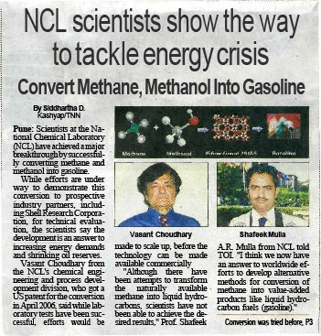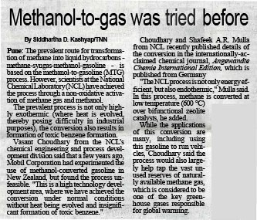

### *4.5.9.8. References:*

1. Choudhary, V. R., et. al., (2005), Simultaneous Conversion of Methane and Methanol into Gasoline over Bifunctional Ga-, Zn-, In-, and/or Mo-Modified ZSM-5 Zeolites. Angew. Chem., 117: 4455–4459. doi: 10.1002/ange.200500694
2. http://www.ncl- india.org/ResearchCollaboration/featuredresearch.jsp?odf=2&od=null&LB=10#
3. Personal Discussions with Dr. Shafeeq Mulla.

**Figure 4.5.9.2. *Original article is below:(snapshot of original article)***

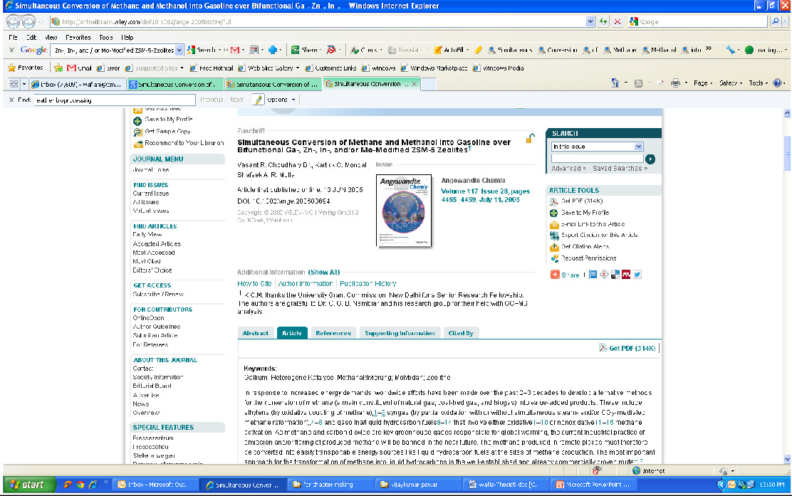

Source: <http://onlinelibrary.wiley.com/doi/10.1002/ange.200500694/full>

# Results of Study

## Methodology Used for Primary Data Scientific Discovery No. 10

**Working on Plants with anti-HIV properties**

### *Problem:*

The tree *Calophyllum inophyllum* known as sultan champa or laurel tree does not attract termites and hence, it was being used by the local fishermen for making boats and furniture. Availability of these trees is less due to low rate of germination and seeds are being washed off the shore. The local people were not aware of the importance of this tree and therefore they were not interested in cultivating them.

### *Background:*

The tree is found along the western coast of India in states such as Maharashtra, Kerala and Tamil Nadu. Since these trees were being discarded for personal use such as making boats and furniture, researchers from CSIR-NCL decided to study it and found it to be medically important.

### *About the Existing Technology:*

Different parts of the tree have been used in traditional medicine to treat ailments like rheumatism, haemorrhage and skin diseases.

### *Lessons to learn:*

Recent research has shown that compounds isolated from the tree can help fight HIV and cancer.

### *Observation:*

The tree *Calophyllum inophyllum Linn. [Guttifereae (Clusiaceae)],* commonly known as ‘Indian laurel’ or ‘Alexandrian laurel’ is a broad leaved evergreen tree found along the beach crests and sometimes found to be occurring on inlands. Calophyllum species are gaining importance as a source of anti-HIV medicines.

### *Method:*

To propagate the tree, the scientists collected mature fruits and extracted the seeds from the hard cover. They germinated these seeds in vitro. The germinated seeds were then successfully planted in the CSIR-NCL campus. The technique holds a high regeneration potential for the tree. Dr. Mrs. Thengane, Scientist, said they look forward to collaborating with pharmaceutical companies and interested organisations for large-scale propagation of this medico-economic tree.

### *Contribution from CSIR-NCL:*

The tree is known to have cancer chemopreventive agents, coumarins and xanthones with antimicrobial activity. The oil found in the tree is found to have medicinal properties and can be used to treat ailments like rheumatism, skin diseases, joint pains and haemorrhage. The aqueous extracts of the root bark and leaves are used for healing scars whereas the fruits contain analgesic properties and are therefore used in treatment of wounds and herpes. The oil is also used as luminant, lubricant, for soapmaking, etc. The timber is used for beams, furniture, railway carriages and shipbuilding.

### *Publicity:*

1. Paper publicity on 30th June, 2006 in ‘Down to Earth’
2. <http://www.downtoearth.org.in/node/7995>

## Figure 4.5.10.1. Article appeared in ‘Down to Earth’ dated 30th June, 2006. (paper clipping for popularization purpose)

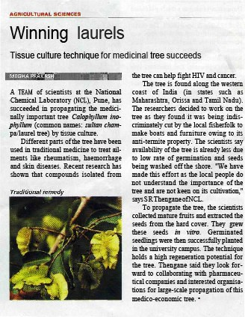

### *References:*

1. S. R. Thengane, et. al., Current Science, 90:10, 25 May 2006, ‘Micropropagation of Indian laurel (Calophyllum inophyllum), a source of anti-HIV compounds’.
2. Pawar KD, et. al., Journal of Biotechnology 130 (2007) 346–353, Pattern of anti-HIV dipyranocoumarin expression in callus cultures of Calophyllum inophyllum Linn.
3. Personal Discussions with Dr. S. R. Thengane at CSIR-NCL.
   * For further details kindly contact Dr. Mrs. S. R. Thengane at [srthengane@gmail.com](mailto:srthengane@gmail.com)

**Figure 4.5.10.1. *Original article is below: (snapshot of original article below).***

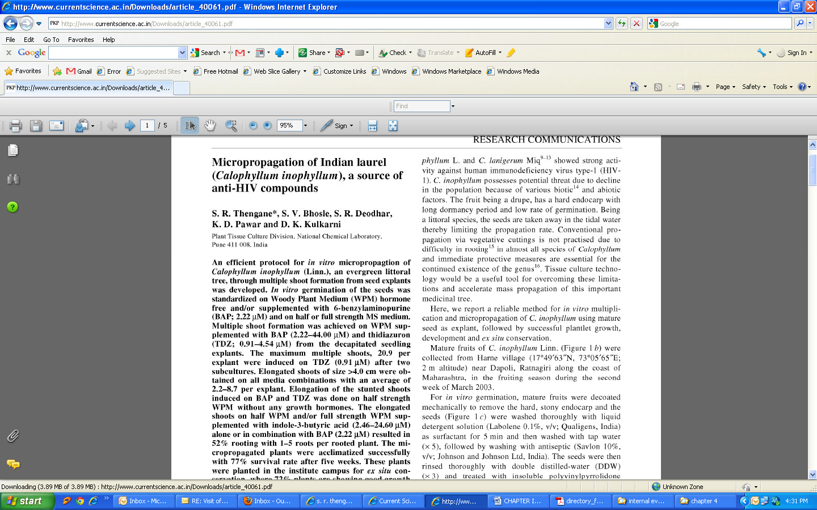

Source: [http://www.iisc.ernet.in/~currsci/may252006/1393.pdf](http://www.iisc.ernet.in/%7Ecurrsci/may252006/1393.pdf)

# EFFORTS BY RESEARCHERS / SCIENTIST FOR POPULARISATION OF SCIENCE

The researcher or scientists have to perform special tasks in order to popularize science. Since they are already bounded by research work they find little or no time to carry out the popularization. The following are some of the efforts that need to be carried out by the researcher or scientist for popularization.

1. The scientist needs to discuss the article with the science communicator or media
2. The scientists needs to spend time to explain the paper without using technical language
3. The scientists has to ensure that the draft of the article is not over-emphasized
4. The scientist should suggest type of audience based on the draft of the article
5. The scientist should either seek help from the institution where the research is being carried out, or encourage the institute to take interest towards popularisation activities.
6. The institution should appoint a public relations officer who should be given the task of sending important research findings in the form of press release, publicity etc.
7. Alternatively the research institution may appoint a science communicator full time who may be given the responsibility of popularizing science
8. Follow up on getting it uploaded on the website for popularizing purposes
9. Make a documentary or a film based on the popularized articles using graphics to make it audience centric
10. Bring out newsletters, popular articles in non scientific magazines
11. Rewrite article for student audience for publicity and motivation
12. Make use cartoons for publicity amongst the school students

# 4.7 CONCLUSION

Methods of popularising scientific research was identified keeping in mind the impact and use of the popularization to common readers. Scientific articles are written by research scholars to record their findings and popularize the same amongst its peers. The scientist is interested in writing findings of its research so that another researcher does not use the same method for finding out the result of a problem. Scientist take interest in recording research because their work gets due recognition from the scientific community thereby making way for working on similar problems for different applications. There are plenty of advantages to scientist and research scholars who publish a paper and more efforts go in popularizing the research.

Sincere efforts were taken to publicize the research article. All the ten articles taken up for study were either popularized in non scientific journals or in local newspapers while some of the articles were part of the journal cover pages. Through means of secondary sources, the students and common people took equal interest in reading these articles in the newspaper, television and other forms of media’s like newsletters, websites etc. The students and common people were aware of dissemination of scientific articles but were disappointed with the amount of scientific research that was actually publicized. The students and common people felt that a separate ‘science news’ newspaper focusing exclusively on science should be made. The students were hungry for science news that came directly from the science fraternity.

Scientist is reluctant to give time for a non scientific activity. According to them popularizing science is a non scientific activity and spending time on such an activity leaves less time for research. Besides every scientist or a researcher spends part of their time in preparing a proposal, charting out the materials and chemicals to be used, following up with deliveries of these items are a priority to their research. Spending time with students and directing them to achieve results, carrying out safety measures, monitoring the overall scientific activity is itself a cumbersome task. When deciding to popularize, they have to first speak in a simple language which is difficult for them as they are immersed in the scientific jargon, simplifying becomes difficult for them. Interacting with common people enables them to bring down their research terms in a simple language. Because of lack of time they are unable to deliver their research findings in an

appropriate simple manner to the press and science communicators even though they are important to common people and are researched by scientist keeping in mind the application for common people.

The efforts and interest if seriously taken by scientist or research community towards popularizing their research findings can make research popular among the non scientific community. For this to happen, the scientist, research scholars, researchers should write an article parallel to its research using simple language that could comprise of a small paragraph that can be used in newspapers, websites and also form short stories for school children.

The following parameters were tested from the experiments that were undertaken for converting ten scientific research abstracts in simple prose. The conclusions that were drawn in the parameters are taken from primary and secondary analysis.

1. Language:

Out of 320 students, all the students felt that language for writing the research was important. They felt that simple and easy to understand language was lacking throughout in the article. The students felt that the title of the research article was also complicated. They could not understand the title completely and that it only helped in giving them an idea of the overall subject of the paper.

The analysis showed that a simple title would enhance the reader to get interested in reading the paper. Also, the abstract of the paper was not easy to understand.

When the students were informed by the researcher that the article was meant for scholarly audience and not for students or common people, their reaction was that even they wanted to know of the scientific discovery that was written in the paper. They wanted to be part of the audience as readers to it. The students and common people felt that if the complete article was written keeping in mind the scientific fraternity then at least the abstract should be rewritten for the common fraternity. This means that the scientific article format should be rethought to accommodate common people.

1. Understandability:

An article was given to the students and common people to understand and discuss its implications. The students were not able to understand it fully. Then an analysis of the article from this study was given to them and again the same sets of questions were asked, this time they were able to completely understand the research article.

The students felt that the research article was important and it had helped them acquire new knowledge. They felt that the findings of the paper and the topic of research both were important to them. They felt that they could easily relate to it after it was explained to them by the researcher. The students felt that scientist should come and talk to them and help them understand the research publications, they felt that scientist should at least write a paragraph on their achievements they have achieved during research, and this information will help the students and common fraternity.

1. Relation:

The experiments of the articles were related to the common people and students. The community could relate to the abstracts and felt that it was a useful pool of information that they were being deprived of.

1. Simplicity:

The experiment after explaining to the common people and students was simple but the research article was extremely tough.

1. Usefulness:

The experiment was extremely useful. The articles when given to students and common people for reading were appreciated and pressure for scientist to interact with them was constantly being felt. The students and the common people said that they read news of science in the newspaper but the article had given them a different outlook and they felt they understood the plight that went through researchers for carrying out a research which was useful for them.

1. Publicity

The articles were published in newspapers and magazines for publicity purposes. They were also read by the students and common people. The research institutions, academicians and laboratories where research is performed are encouraged through this study to publicize their research as much as they can.

All the students irrespective of their area of specialization were interested in knowing the scientific discovery; they were also interested to have a special edition exclusively for covering research discoveries in simple prose.

The experiments used in the study were all relevant to the common people. It was found that they were publicized in local newspapers and articles were publicized in simple language on the website.

********